

**Tobor Inc**

**‘ZEO’**

**Detailed Process Description**

**Version 3.0**

**Revision History**

|  |  |  |  |
| --- | --- | --- | --- |
| Date Issued | Version | Description | Author |
| **13/06/2020** | **1.0** | **Draft** | **Nik Jeewon** |
| **19/06/2020** | **2.0** | **Draft** | **Nik Jeewon** |
| **25/06/2020** | **3.0** | **FInal** | **Nik Jeewon** |

**Contributors**

**The content of this document has been authored with the combined input of the following group of key individuals.**

|  |  |  |
| --- | --- | --- |
| Name | Role | Area |
| **Nik Jeewon** | **RPA Consultant** | **QA Ltd** |
| **Chris Lucas** | **Project Liaison** | **QA Ltd** |
| **Roberto Fernandez** | **Backend Application Manager** | **Tobor Inc** |

**Business Sign-off**

**The following table contains the people required to sign-off and/or review this document and those that require the document for information only.**

|  |  |  |
| --- | --- | --- |
| Name | Department | Responsibility |
| **Chris Lucas** | **QA Ltd** | **Peer Review / Sign Off** |
| **Nik Jeewon** | **QA Ltd** | **Review / Sign Off / Information** |
| **Roberto Fernandez** | **Tobor Inc - Onboarding** | **Information** |

**Document Classification**

|  |  |
| --- | --- |
| Classification | Confidential |
| **Definition** | **Information on DPD is Company Confidential. Only select few can access Document. Developing automation to work with organisation processes and customer data.** |
| **Context** | **Through loss of information confidentiality, organisation’s sensitive processes could be accessed - damaging organisation brand and leading to loss in every category. Through GDPR, customer data will be kept - loss of user data can have more substantial repercussions.** |
|  |  |

**Contents**

**1 Introduction** **4**

**2 Manual Process** **4**

**2.1 Overview** **4**

**2.2 Detailed Process Flow** **4**

**3 Automation Proposal** **4**

**3.1 Overview** **4**

**3.2 Automated Process Flow** **5**

**3.3 Target Systems & User Requirements** **5**

**3.4 Impacted Business Areas** **7**

**3.5 Workload** **7**

**3.6 Operational Constraints** **7**

**3.7 Delivery** **7**

**3.8 Contact List** **7**

**4 Automation Details** **9**

**4.1 Automation Walkthrough** **9**

**4.1.1 User Journey** **9**

**4.1.2 Content aggregation (Daily)** **12**

**4.1.3 Content aggregation (weekday)** **16**

**4.1.4 Merging pdf and emailing** **16**

**4.2 Reporting** **18**

**4.2.1 Business Exceptions** **18**

**4.2.2 System Exceptions** **18**

**4.2.3 Performance** **19**

# **1 Introduction**

**ZEO is setting the standard for content delivery applications and has been extremely well received due to its efficiency, accuracy and factual nature of the content delivered. The application relies heavily on backend interaction and administration, making it a strong candidate for process automation. This document will focus on these backend processes including user signups, aggregation of content delivery and reporting. The content aggregator collects content (small bulletins of information) from particular websites based on the User’s preference. Backend processes will be automated such as collecting information, aggregating content and reporting. This DPD will outline the manual processes that are involved and the methods that will be used when developing the automation.**

# **2 Manual Process**

## **2.1 Overview**

**When a User requests to CREATE, DELETE or REMOVE on the app, their details are sent to the company to begin the process. The person in the onboarding team will then be responsible for processing the requests and will then carry out the following steps:**

* **Check Company email account for CREATE, DELETE, REMOVE requests. Email will be received in template.**
* **Alter Company database with new requests**
* **Sends confirmations back to User**
* **Collects relevant content based on User preference**
* **Tidies content ensuring clean data and no repetitions**
* **Sends content to User based on preference and interval**
* **Records all user interactions**
* **Records content transmissions**
* **Compiles PDF to collate report.**

## **2.2 Detailed Process Flow**

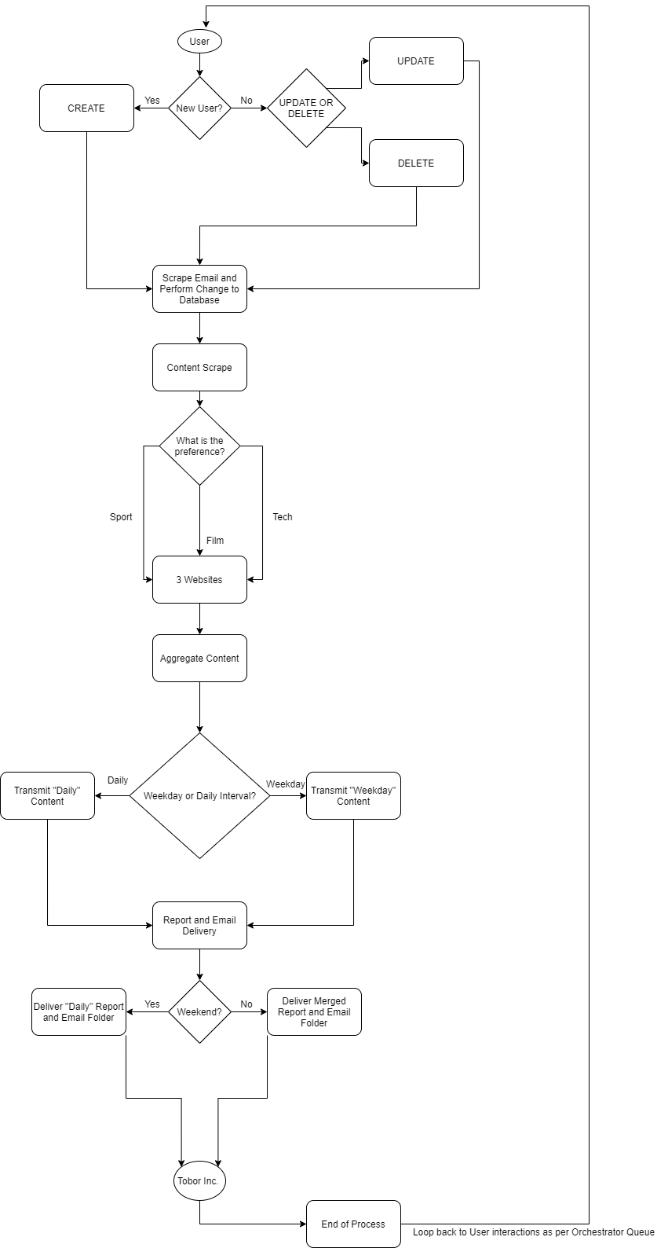

# **3 Automation Proposal**

## **3.1 Overview**

**Manual process shows process split into three sections - User Journey, Content Collection, Reporting. QA Ltd propose to automate all sections and use Orchestrator to trigger the automations at certain intervals. It is important to note that due to the complexities surrounding the content interval schedule (Daily and Weekdays) and the use of only one Robot - the processes will include two queues, one for the daily individuals and one for the weekly individuals. Further, the automation proposes to capture any email failures into a local folder to be manually managed.**

**Process 1 (Beginning at trigger time and cutting off at 11:30am for Process 2); (Process will continue once Process’ 2 & 3 have completed, until 11.30am the following day; Process 1 will constantly run and update the database, in a cyclilar fashion)**

* **Read Company Mailbox**
* **Scan email subject for relevant User requests - CREATE, UPDATE, REMOVE.**
* **Scrape data from email template received**
* **CREATE = Create User, UPDATE = Update any User details, REMOVE = Remove User from Database.**
* **Inject newly updated database into suitable format - MS Excel for interaction ease.**
* **Send confirmation receipt to User**
* **Log any User changes/creations/removals to collect into daily collated report**

**Process 2 (Triggers at 11:30am and will run till completion of Daily and Weekday Queues - Average Time = 10 minutes)**

* **Open Browser**
* **Select websites for content based on User preference**
* **Collect data from websites**
* **Tidy data for transactions and ensure no repetition of data**
* **Content will automatically be placed into email and sent to those with reference to User requested interval (Daily)**
* **Orchestrator will be used to manage transactions, giving the company additional logs and extra information**
* **Automation will run through triggers, UiPath will use Orchestrator to organise relevant timings.**
* **Automation will access relevant information to build report**
* **Process 2 & 3 will provide an exported PDF report**
* **Excel workbook will be created containing details on any Email Delivery Failures.**

**Process 3 (Will trigger directly after the Daily process and perform the same as above but for those who require content on Weekdays)**

**Process 4 (Triggers directly after content has been sent and logged; Once complete, Process 1 will re-trigger and begin it’s database operations)**

* **The automation will merge the Daily and Weekday PDFs to form a collated report.**
* **Exception handling will be used to organise the correct email attachments to be said in regard to the content interval**
* **Email will be sent to the Company account. containing relevant reports and email success/failure.**

## **3.2 Automated Process Flow**

**Automation will mimic the manual process; However, automation will also include any Email delivery failures that will be handled into a local folder. Daily Report will be received everyday, rather than when time is not an issue.**

## **3.3 Target Systems & User Requirements**

|  |  |  |
| --- | --- | --- |
| Name | Description | User Permissions/Access |
| **MS Outlook**  **Gmail** | **Company Email Inbox**  **User Email Inbox** | **No Permission Required for developer purposes. Account will be replaced with the Company account.**  **Simulates a User account for development purposes. No Access permissions required** |
| **MS Excel**  **Configuration Files** | **Tool used to Mimic User Database**  **Notepad file to configure dynamic assets** | **No User permissions required**  **No permission required** |
|  |  |  |

## **3.4 Impacted Business Areas**

* **Backend Application Management**

## **3.5 Workload**

**Metrics related to the automation, table example below**

|  |  |
| --- | --- |
| **Max. no. of Login Requests per Day** | **35** |
| **Min. no. of Login Requests per Day** | **25** |
| **Average no. of Login Requests per Day** | **30** |
| **Are there any periods when a higher workload is anticipated?** | **Holidays, Major news stories and sporting events.** |
| **How many people do this process per day?** | **1** |

* **15 mins per CREATE, REMOVE, UPDATE.**
* **Content Aggregation takes up to 2 Hours.**
* **Sending Emails to the correct User’s = 2 Hours.**
* **Reporting is done when time is a non-issue; averages around 1 hour.**
* **CREATE, UPDATE, REMOVE = 15 Mins x 35 = 525 / 60 = 8.75 hours per day.**
* **Content Agg’ + Sending Emails = 4 hours**
* **Reports = 1 hour**

**Automating the steps below will realise an average time saving of 825 minutes (13.75 hrs) per day for User Journey, Content Aggregation and Reporting.**

**Acronyms – detail the meanings of any acronyms used above e.g. systems, clients etc.**

## **3.6 Operational Constraints**

* **Content must be clean and provide no repeats**
* **Website Scraping if website is down**
* **Email delivery failures**

## **3.7 Delivery**

**The automation will go live on the 29th June 2020.**

## **3.8 Contact List**

**QA Ltd - RPA Consultant – Nik Jeewon Tobor Inc. - Backend Application Manager & Project PM - Roberto Fernandez**

**QA Ltd - Consultant Project Liaison - Chris Lucas Tobor Inc. - Managing Director - David Bradbury**

# **4 Automation Details**

## **4.1 Automation Walkthrough**

### **4.1.1 User Journey**

* **A fake database will be created to mimic that of the Company.**
* **The automation will access the company email account and filter through User requests by the subject of CREATE, DELETE and UPDATE.**

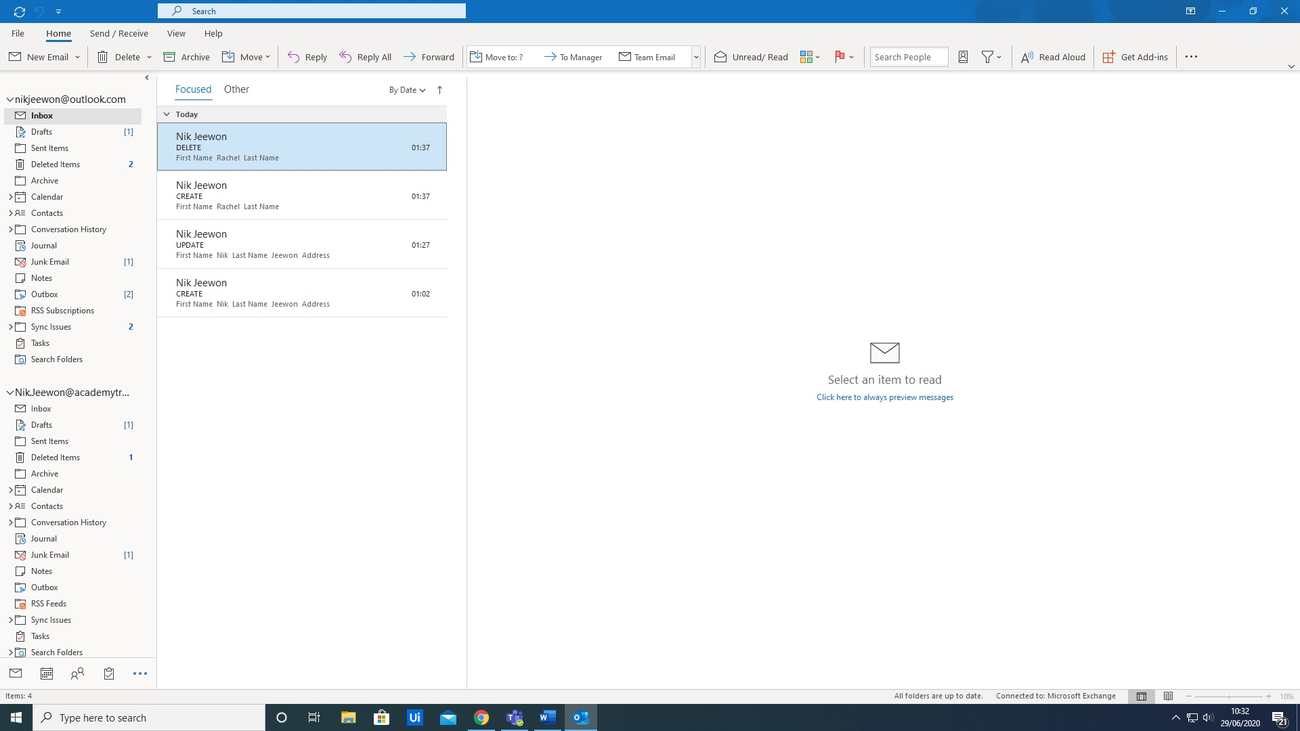

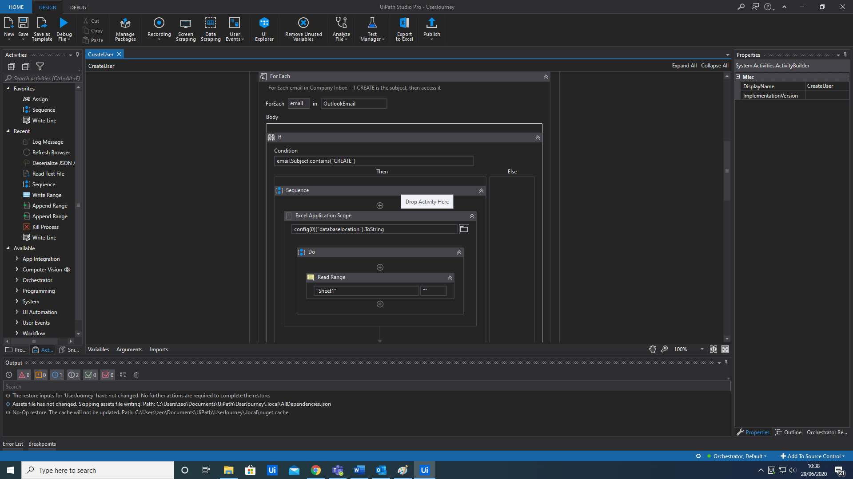

* **The body of the email (which comes in the format of a table will then be scraped and split to build a datatable in the program.**

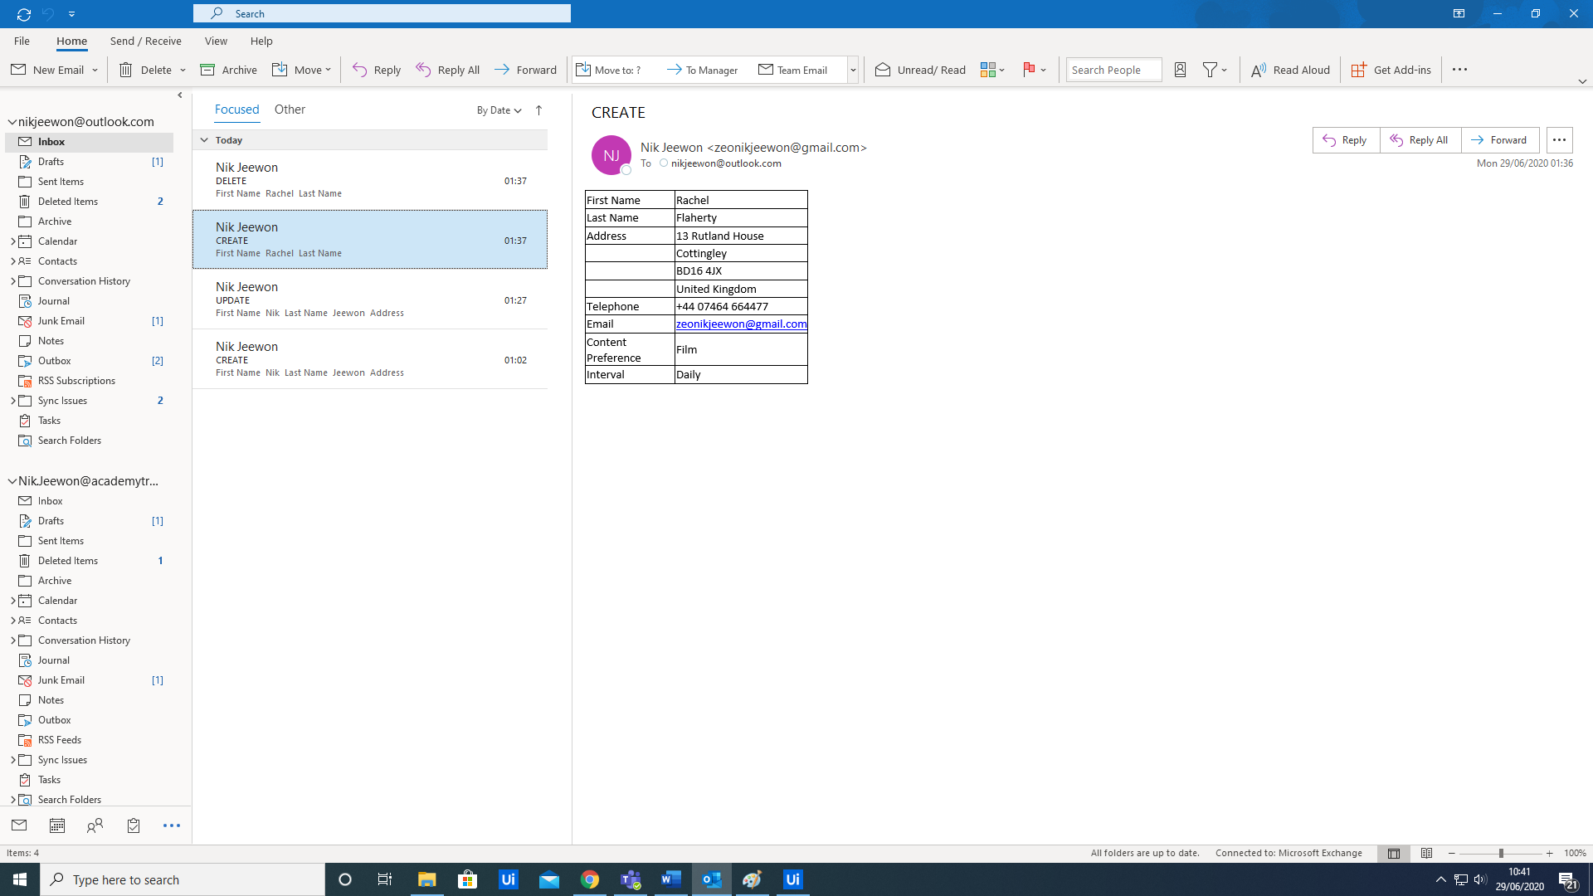

* **If the subject contains CREATE, this will then be inserted into the fake database as a new user. Through the use of adding a new datarow.**

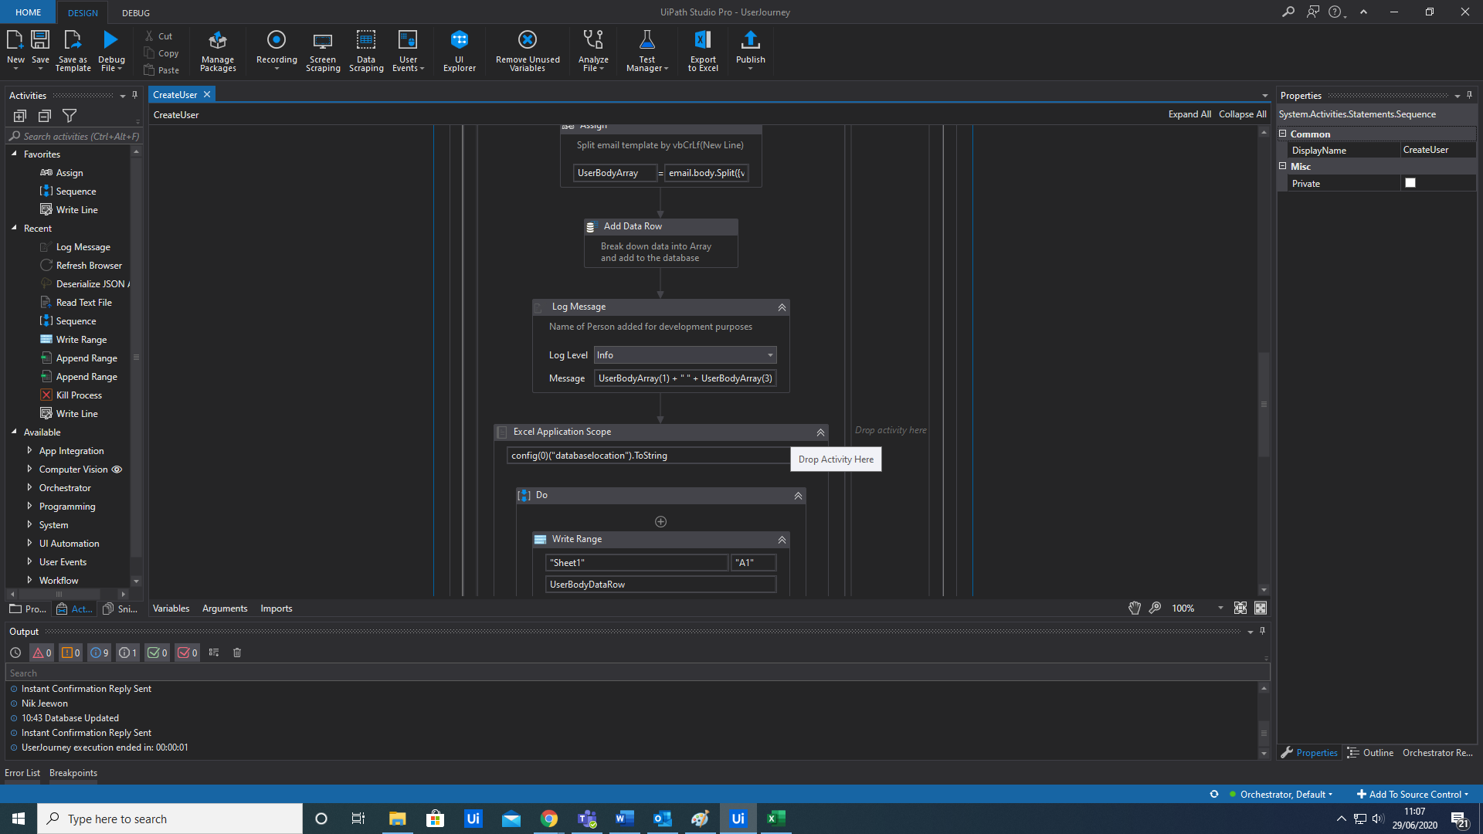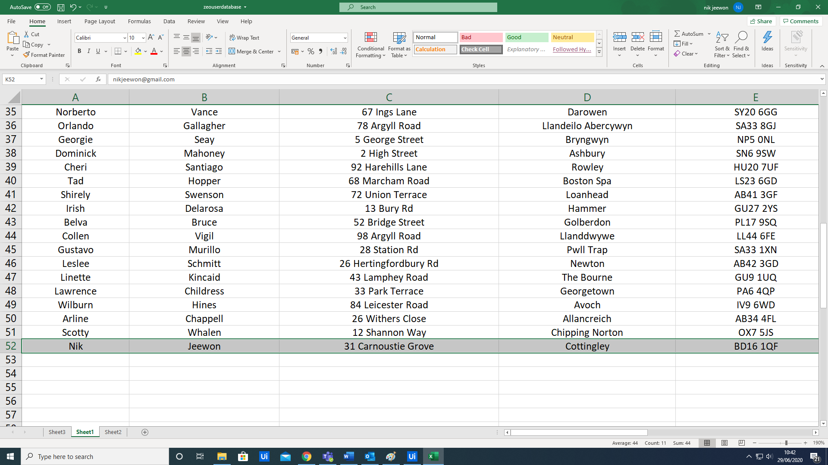

* **If the subject contains DELETE, this will remove a row from the database buying “Looking Up” the row index of the Unique ID. In this case, it is their email address.**

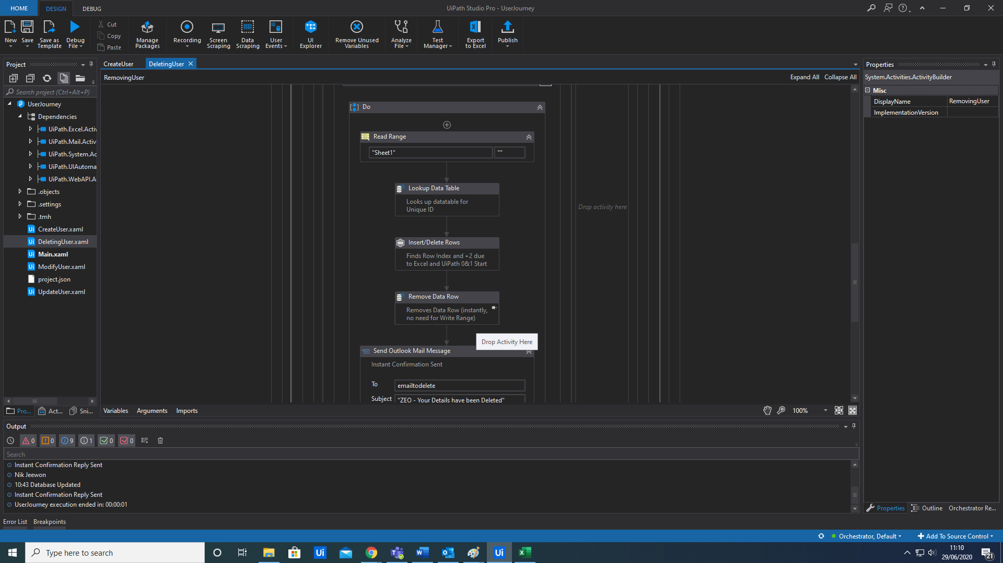

* **If the subject contains an UPDATE, the row again will be removed by the Unique ID, but will be replaced by iterating through the new body of the email and injecting it into the database.**

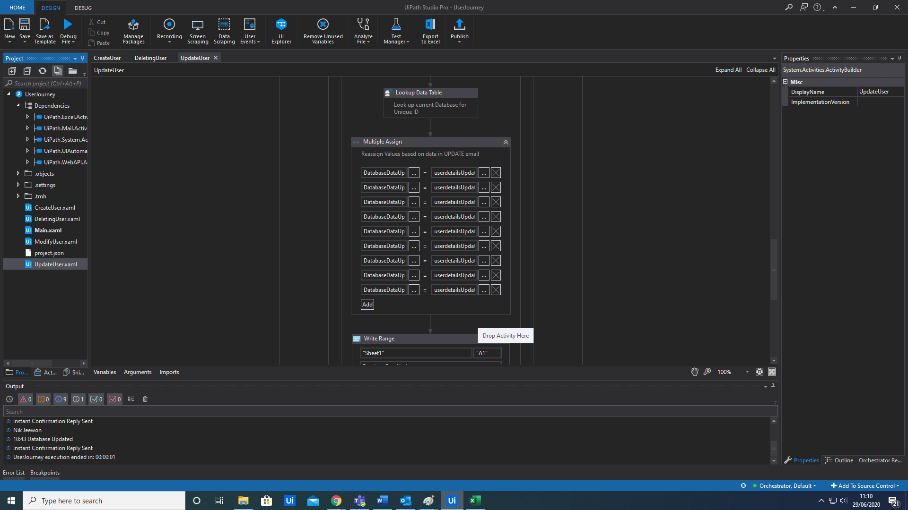

* **Once updated, the automation will then send a confirmation back to the User, explaining that the action (CREATE, UPDATE, DELETE) has been performed.**

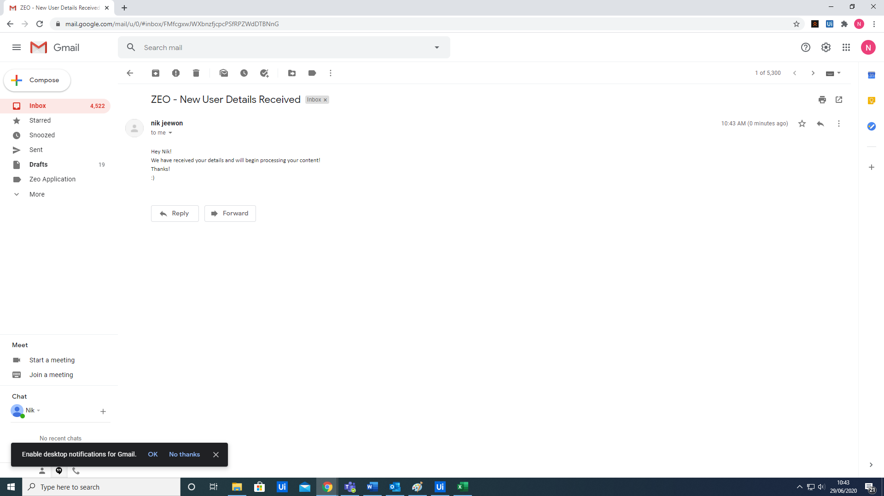

### **4.1.2 Content aggregation (Daily)**

* **The robot would then proceed to add the database items to the Orchestrator queue to begin processing.**

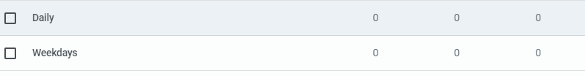



* **Once the database has been completely updated and the queue added, the next scheduled process is to gather the content necessary for the app to send out to its Users.** 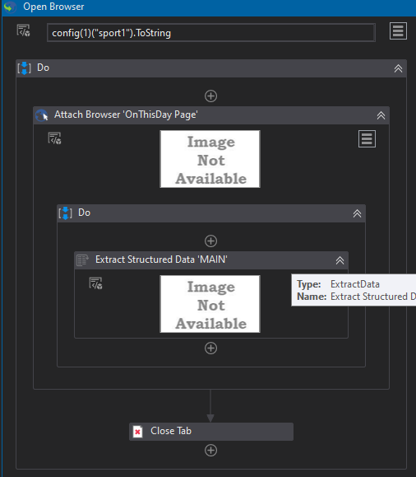
* **The robot will scrape information from websites - a total of 9 were used for development purposes, 3 for each content category (sport, film, tech).**

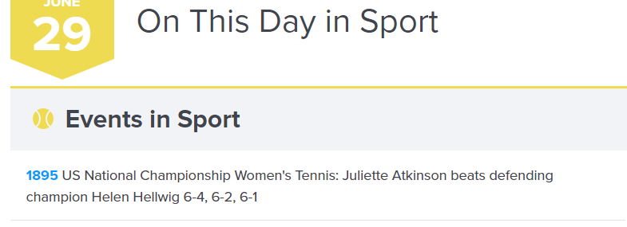

* **“Processing” would refer to each email containing content being sent out to the User, based on their preference.**
* **The robot will then access the queue in Orchestrator and use a “Flow Decision” to and a loop to iterate itself through the queue items.**

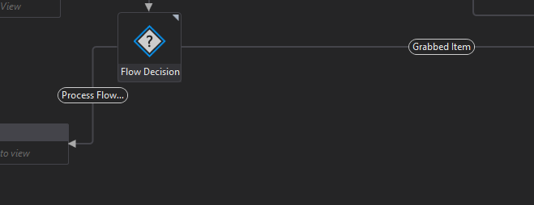

* **It will take each item and filter through Sending the email based on their content preference. It will also use an IF statement to filter out those who have “Daily” as a content interval request.**

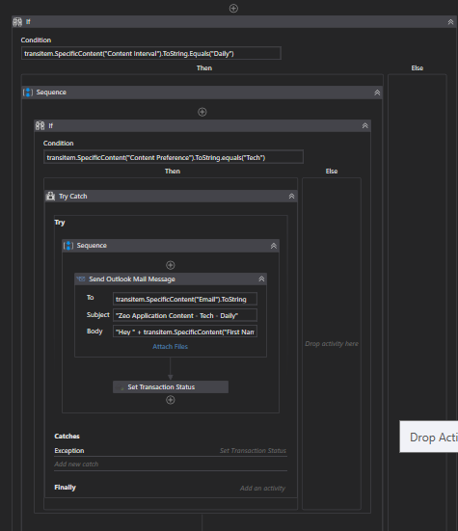

* **It will then “Set Transaction Status” to “Successful”. Should any email fail to send, a trycatch is added to catch the exception and “Set Transaction Status” to “Failed”.**
* **The Report will be then accessed through the use of the “Sent Items” and “Inbox”. The email bodies and subjects will be trimmed down to give the report necessities.**
* **This will then be added to a Word Document, using a DateTime stamp and finally converted to a PDF for the “Daily” Report.**

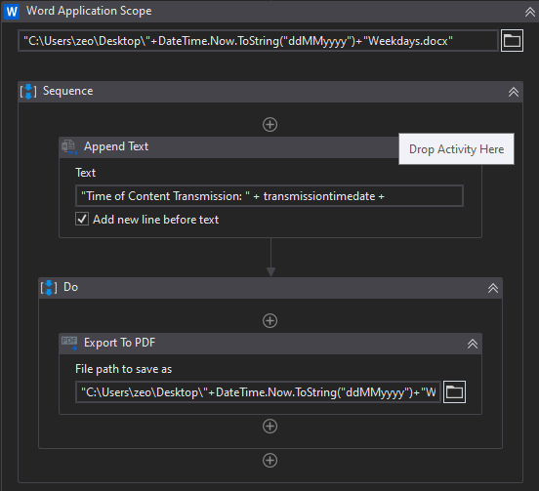

* **A workbook will be created using the “Get Queue Items” activity, where it will filter out particular information in order to build a Email Delivery Failure workbook for the Company to manually keep.**

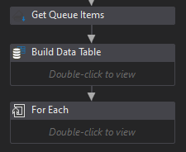

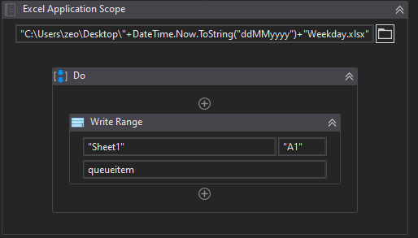

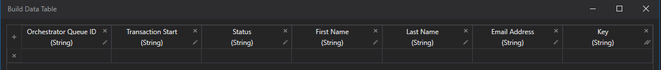

### **4.1.3 Content aggregation (weekday)**

* **This will perform the same actions as above but will filter out those individuals who want their content for Weekdays. This will of course be queued through Orchestrator, through 2 separate queues.**

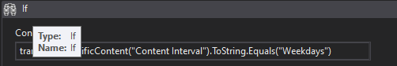

### **4.1.4 Merging pdf and emailing**

* **Both the Daily and Weekday PDF will then Merge and be emailed to the Company account.**



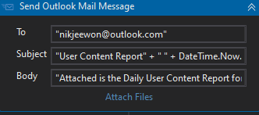

* **The Email Failure workbook will also be emailed. They will receive one for Weekdays and one for Daily content intervals. On Weekdays, they will only receive the Daily email success rate workbook. This can be adjusted for the Company requirements and storage.**



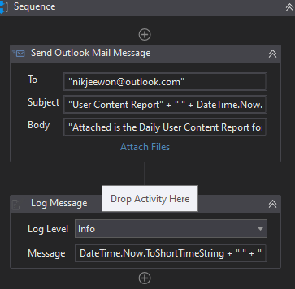

* **However, should the email be sent on a Non-Weekday - there will be no Weekday File to Merge, causing an exception.**
* **A Try Catch is added to catch the exception and then send an instant email to the company just containing the Daily report and email success rate.**
* **The Catch is then instructed to kill the process, to avoid moving to the original send email activity.**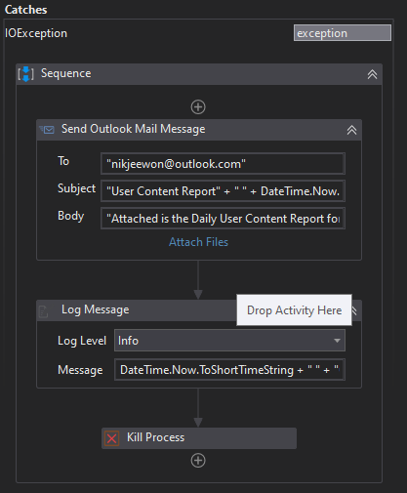

## **4.2 Reporting**

### **4.2.1 Business Exceptions**

|  |  |
| --- | --- |
| **Exception** | **Solution** |
| **Websites hanging during content scraping** | **Exception added to refresh webpage** |
| **Missing Data in Scraped templates** | **Split Strings by vbCRLf, rather than spaces.** |

### **4.2.2 System Exceptions**

|  |  |
| --- | --- |
| **Exception** | **Solution** |
| **Orchestrator Cloud issues** | **Send Company xaml files to manually trigger** |

**A performance report will be emailed to Roberto Fernandez each time the process runs (showing worked cases, exceptions and a cumulative processing log)**

### **4.2.3 Performance**

**Once the processes have successfully completed a performance report and processing log will be emailed to Roberto Fernandez as an excel file.**

**Performance Report**

**This will contain all exceptions (business and system) and successes for the automated Process, based on the last automation execution completion (i.e. based on the last time the process ran)**

**EXAMPLE REPORT**

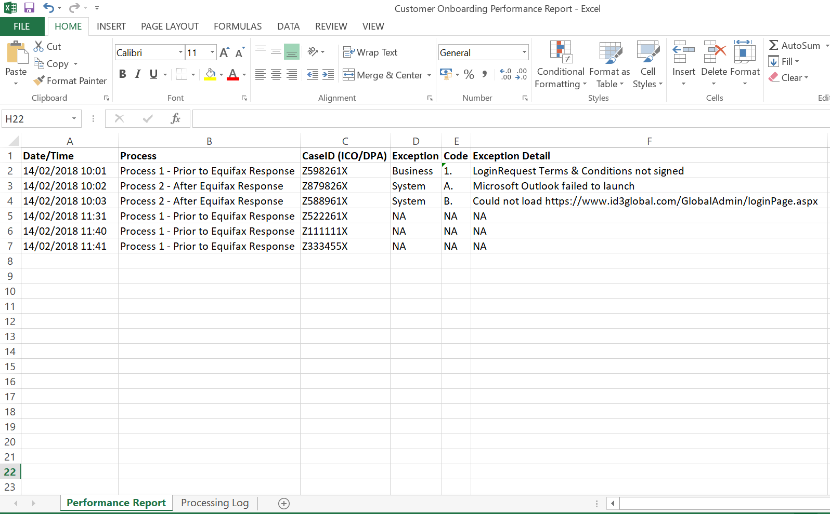

**Processing Log**

**This will show cumulative successes from the automated Process:**

**EXAMPLE REPORT**

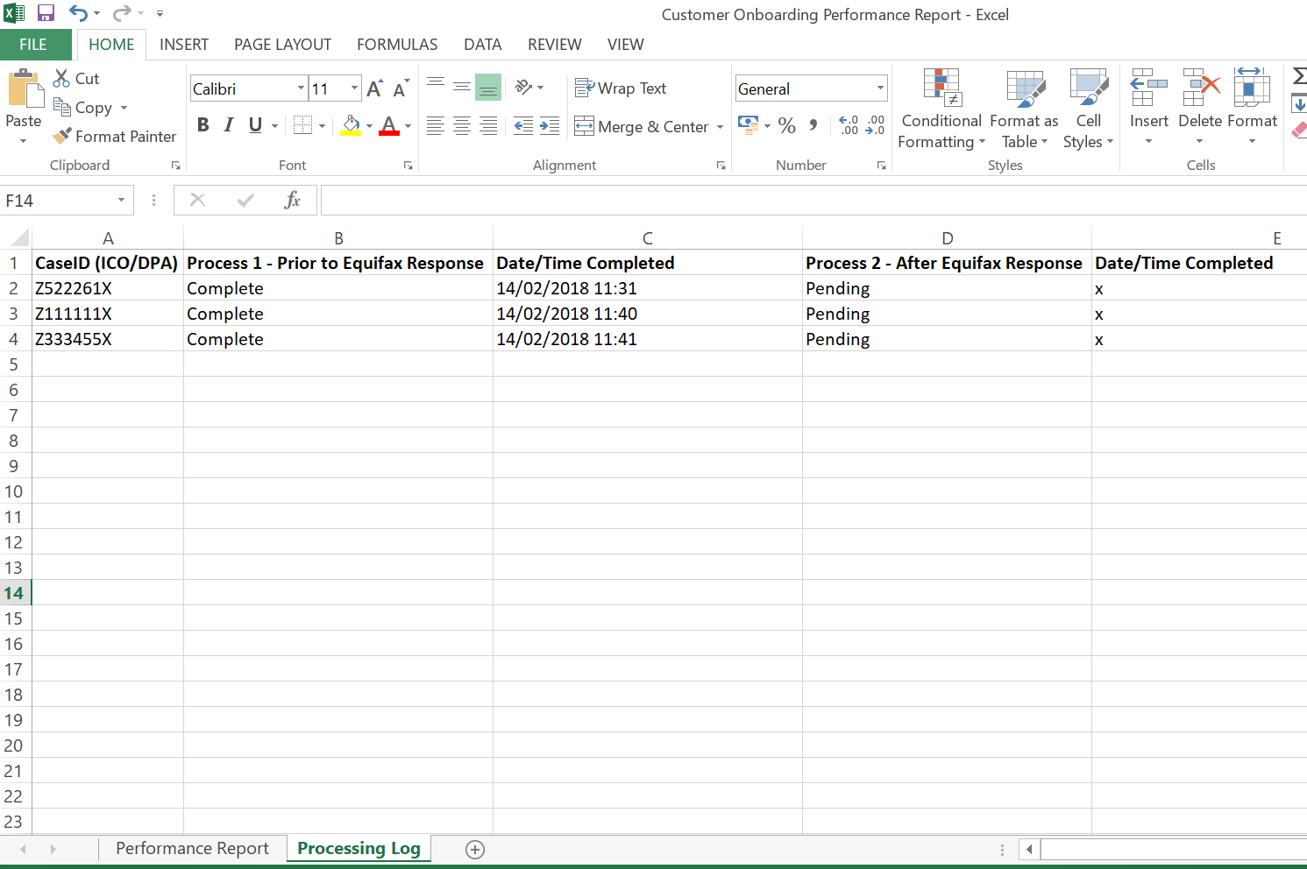

**Triggers**

* **The CREATE/UPDATE/REMOVE process will be triggered and left to run and will only stop at 11:30am when the Content Aggregation Daily Process is triggered.**
* **This will be followed by the Weekday Content Aggregation (however, during the weekend Orchestrator will schedule this process, not to run).**
* **The merging PDF and email is triggered after the Content Aggregator(s).**
* **Once complete, CREATE/UPDATE/REMOVE is then re-triggered, until 11:30am the following day - when the cycle repeats once more.**